**INCIT BACKEND TEST**

HOW TO USE APPS :

1. Install node, and dependencies, check package.json.
2. Install local MySql.
3. Clone repo.
4. Create database in my sql with table name : incit_backend, and column name users.
5. Run app using “nodemon server.js”.
6. Access root using GET (localhost:8080/)
7. Access sign up using POST (localhost:8080/api/signup)

Please look at this image below, this is the correct result (if password consist one number, one special char, one uppercase, and lower uppercase, and also 8 length

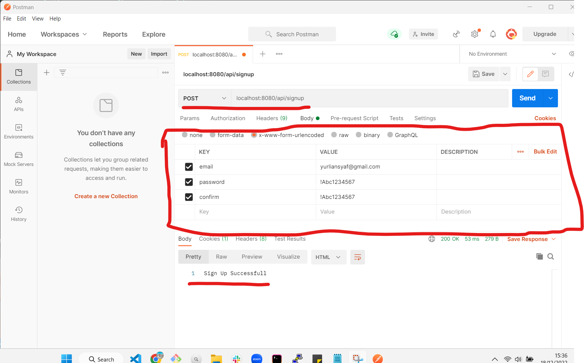

1. And this is the example if password is not correct

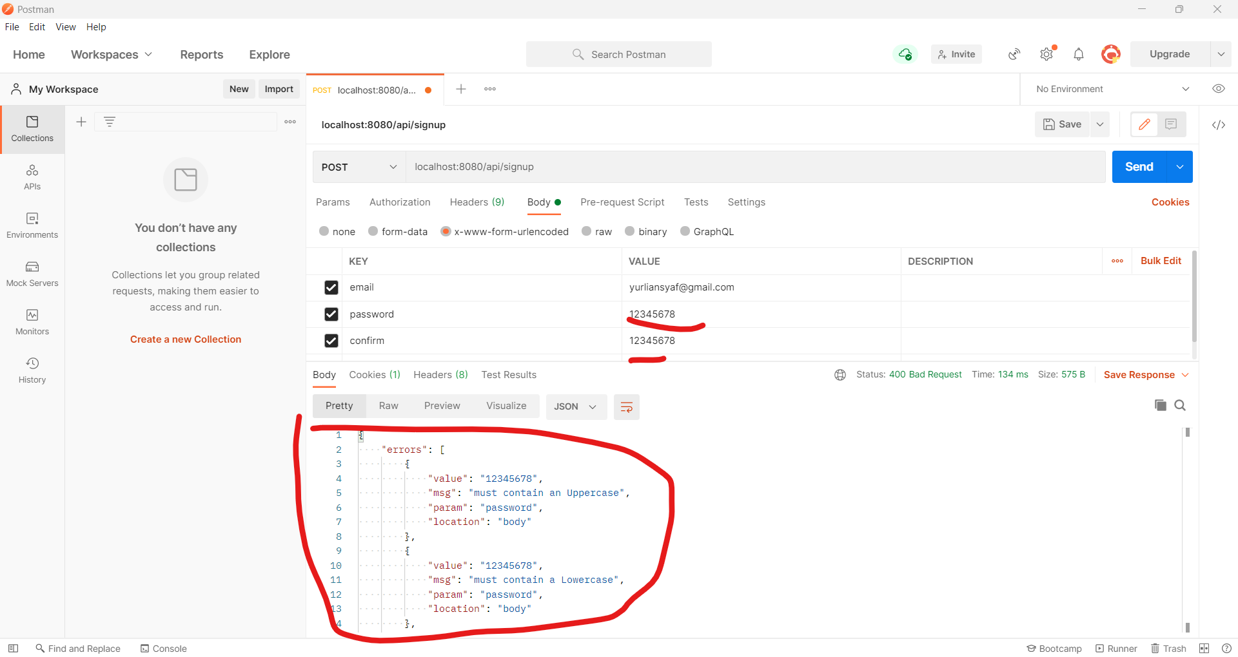

1. For email, im using mailtrap for fake smtp server and this is the email

